Link Quality Estimation for Industrial Wireless Sensor Network using Burstiness Distribution Metric
Ngoc-Huy NGUYEN¹ and Myung-Kyun KIM¹
¹ University of Ulsan, 44610 Daehak-ro 93, Nam-gu Ulsan, South Korea
{huynguyen.haui1412@gmail.com, mkkim@ulsan.ac.kr}
Abstract. As the mature of Industrial Wireless Sensor Network applications are increasingly requiring about low-power operations, deterministic communications, and end-to-end reliability. However, it is very difficult to achieve this goal because of link burstiness and interference. In this paper, we propose a novel link quality estimation mechanism namely Burstiness Distribution Metric which uses the distribution of burstiness in the link to deal with the variations in the link quality of Wireless Sensor Networks. First, we estimate the link quality by counting the number of consecutive loss packet happenings in each bi-direction link at the receiver node. Then, based on that the node decides to choose the best route for the routing and estimate the number of retransmission to reach the reliability target in the scheduling algorithm. Our simulation in Cooja Simulator – the simulator of Contiki-NG shows that our proposal can be used as the input metric to choose the minimal number of retransmission packet on each link for the routing protocol and calculate the number of retransmission in scheduling to achieve the latency and reliability target in Industrial Wireless Sensor Network.
Keywords: IEEE 802.15.4e, Industrial Wireless Sensor Networks, Link Metric Measurements, Link Burstiness, Reliability.
- INTRODUCTION
Wireless sensor networks are deploying in many applications such as monitoring applications, radiation checks, leakage detection, process control applications, and have some advantages such as low cost and high flexibility when compared with the use of wired networks [1]. In which application, the data is collected by the sensor node and then transmitted to the sink (based station). Especially, in the industrial application, have strong requirements in terms of latency, energy efficiency, and reliability. The reliability of data transmission is decided by the link quality between every two sensor nodes. However, the link quality can be effect by a lot of causes such as internal interference, external-interference, self-interference, and burstiness link. The interference link is the physical property of the environment that causes the packet transmission between different links to interfere with one another. Burstiness link is another physical property which means transmissions of the wireless link do not contain a fixed probability of failure and have periods of continuous loss packet. Because of these non-deterministic wireless links, it's difficult to supply reliability for packet transmit over the wireless networks. Although the causes will make the link quality between two sensor nodes can be changed, however, it is not easy to estimate the link quality between two sensor nodes since the sensor node is limited to the energy consumption and the complexity computational. Therefore, it is necessary to study a link quality measurement that is low complexity computational, low energy consumption for wireless sensor networks.

The routing protocol is crucially important to reduce latency, energy efficiency, and reliability. There are some studies to design a Routing Protocol in multi-hop low power networks such as RPL [2], LOADng [3], LRP [4] to seek effective routes. These protocols have to keep their own foot-print small and select the best way to route for data traffic. So this preliminary link quality measurement needs to be precise and accurate to choose the best route to sink node to achieve reliability target with a low-cost. The author in [5], [6] proposed mechanisms to solve the Burstiness link problem. Srinivasan et al. [6] presented a new metric called β to measure the link burstiness and showed that we can avoid link burstiness by having an inter-packet delay of 500 ms. Though in the industrial area, 500ms of delay is a disadvantage for the network, we don’t have to wait that time to avoid packet loss when link burstiness happens. Munir et al. [5] propose a new metric called maximum burst length (Bmax) as the maximum length of error burst, estimated by using empirical data for a long experiment. The novel routing algorithm called least-burst-route is used in conjunction with this scheduling algorithm to minimize the sum of worst-case burst lengths over all links in the route. However, the algorithm to calculate Bmax value is gathered from the experiment measure link with the long sequence of data-trace before settings the network. It makes this algorithm hard to apply to the ad-hoc network and this algorithm uses the number of retransmission for a packet is too large, so it increases end-to-end delay.
This paper proposes a link quality estimation metric calculated by the receiver node the number of consecutive loss packet then makes the distribution of burstiness of each link. Our proposal can be easy to apply to the ad-hoc network. Moreover, we can use Burstiness Distribution Metric for the Routing Protocol to find the stable parent and for the Scheduling Algorithm to estimate the number of retransmission to reach a reliable target for the specific application. The remainder of this paper is organized as follows. In Section 2, we present some background and related works. The proposed LQE will be described in Section 3. In Section 4, we will show the evaluation result of our method and the conclusion will be given in Section 5.

- BACKGROUND AND RELATED WORK
Link Quality Estimators can be classified into two categories: hardware-based and software-based. The hardware-based estimators are based on information from the physical layer, such as the Received Signal Strength Indicator (RSSI), the Link Quality Indicator (LQI). Their advantage is that they do not require the computation resources since they are built-in hardware metrics. However, hardware-based estimators do not provide accurate measurement as it was observed and reported by previous experimental studies. The software-based estimators are based on upper layers information, such as the Packet Reception Rate (PRR), Required Number of Packet (RNP). Software-based estimators are applied in the sender side or receiver side by counting the number of sent or received packets to calculate the metric for estimators. These link quality estimators are simple and widely used in the routing protocol. For Industrial Wireless Sensor Network the Link Quality Estimator (LQE) needs to be accurate to improve the packet loss ratio, which is costly. The Burstiness Distribution Metric is proposed in this paper to try to satisfy these requirements.
  - Hardware-based Estimators
The IEEE 802.15.4 standard proposed two ways to assess the link quality after receiving a packet which is RSSI and LQI. RSSI is used to describe the power which is presented by received radio signal strength in dBm and coarsely correlated with the distance. However, RSSI only relies on received packets on the receiver side, not account for the number of the lost packet and the interference can influence the RSSI value. The LQI measurement is based on the received packets but the IEEE 802.15.4 standards do not define the computation method for LQI value. The standard only states that the range of LQI value is from 0 to 255. Moreover, to develop a general computation using this metric is very difficult since the different vendor has different ways to calculate LQI value. Some studies used the RSSI or LQI to estimate the channel quality.
Noda et al. [7] proposed a new channel quality metric which is based on the availability of the channel over time and meaningfully quantifies spectrum usage. However, with the presence of multipath fading, it may have problems to estimate the channel quality.
HJ Audéoud et al. [8] studied the correlation between RSSI, LQI, and PDR (Packet Delivery Ratio). The RSSI is a poor indication of PDR that one can expect on a given link, LQI (Link Quality Indicator) gives more accurate information. Thus, the work has focused on the utilization of LQI. However, in scenarios with impulsive noise, the LQI may overestimate the channel quality, since the LQI does not account for the packet loss.
Eskola et al. [9] proposed a classifier to identify disturbances in the wireless channel related to line-of-sight changes and radio frequency interferences. However, the proposed technique does not provide any metric to be used by protocols to optimize network performance.
Gomes et al. [10] proposed a new type of node, the LQE node dedicated to estimating the link quality in real-time using RSSI and information obtained from received packets. Typically, the LQE node is capable of capturing the effects of multipath, interference, and link asymmetry. They use the RSSI and LQI values to infer the Packet Delivery Ratio (PDR) of the given links. Unfortunately, RSSI and PDR have been proved to be only loosely correlated in many situations.
  - Software-based Estimators
The software-based estimators such as PRR and RNP are based on the calculated information from the upper layer. The use of PRR-based metrics for links with very high or very low quality can be achieved with narrow time measurement. However, intermediate links need much larger measure time to accurate link quality estimation. The RNP is more reactive than PRR, it is calculated based on the transmitted packet in the sender side. Thus, RNP can estimate the link quality as long as the traffic is generated from the sender. However, RNP can underestimate link quality since packets are retransmitted many times before being successfully received. This situation yields to good PRR but bad RNP. The Window Mean with Exponentially Weighted Moving Average (WMEWMA), Expected Transmission Count (ETX), and 4-Bit Link are some examples of RNP-based estimators. The WMEWMA is a filter-based link quality estimator that uses the Exponentially Weighted Moving Average (EWMA) filter as the main estimation technique, based on link measurements, the PRR is computed and then smoothed to the previously computed PRR using the EWMA filter which provides a more stable but sufficiently agile estimation compared to PRR [11]. The Kalman filter based link quality estimator (KLE) was proposed in [12] to overcome the poor reactivity of average-based LQEs, including PRR. The ETX [13] is a receiver-initiated estimator that uses active monitoring. The ETX considers link asymmetry by estimating the PRR in both directions to calculate the PRR of the backward link and the PRR of the forward link. However, [14] found that ETX based on passive monitoring fails in overloaded (congested) networks since a large number of nodes are not able to compute the ETX because they do not receive packets. The Four-Bit (FB) [15] Link estimation is designed with four bits of information. The first bit is obtained from the physical layer, to identify the quality of the channel in a received packet. The ack bit is from the link layer and indicates whether an acknowledgment is received for a sent packet, and considers forward and backward links. The other two bits are obtained from the network layer and are useful for route decisions. FB assesses link quality as an approximation of the packet retransmissions count by combining two metrics (RNP and WMEWMA) through the EWMA filter. A simulation study was performed to compare five different LQEs (PRR, RNP, WMEWMA, ETX, and FB) on the collection tree routing protocol for smart-grid environments in [16]. In the simulations described in the paper, ETX and FB presented a better performance in harsh smart grid environments, since only ETX and FB consider the link asymmetry among the evaluated LQEs. However, they are not considering the burstiness link during their measurements.

- THE PROPOSED LINK QUALITY ESTIMATOR

System Model

We focus here on the converge cast multi-hop networks that consist of one sink and some sensor nodes for tree topology. All nodes are assigned identification numbers during network configuration. All sensor nodes transmit data to a sink periodically along the tree path. Two nodes are said to have a link if they can transmit directly to each other and a link on which a child and parent node communicates together is a tree link.

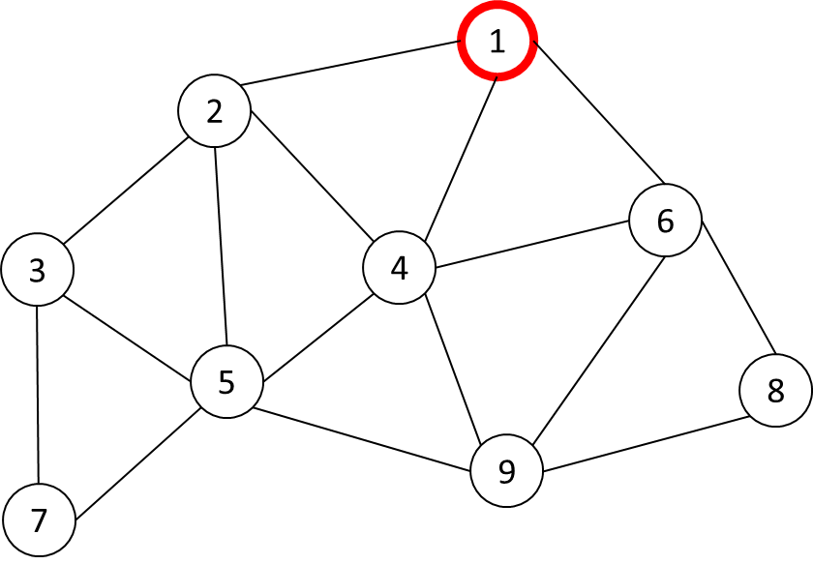
Figure 1. An example network topology.

Given the fixed number of periodic nodes generated sensor data in the network N = {N₁, N₂, N₃, …, N_{n}} with N₁ is the PAN Coordinator and N₂ to N_{n} is the set of sensor nodes. We assume nodes are stationary and deployed randomly. For example, we consider the network topology as shown in Figure 1. If the two nodes are in the radio range of each other, they are connected by an edge. The link between two pairs of nodes N_{i} and N_{j} denoted by L_{(i, j)}.
  - Network construction Period
In the Network Construction Period (NCP), we define the Joining Period (JP) and Measure Link Quality Period(MLQP) as shown in Figure 2. We use the advantage of Orchestra's dedicated schedule based on the fixed number of nodes in the network to make the collision-free in NCP. Orchestra [17] is an autonomous scheduling mechanism where each node independently decides its schedule based on its unique Node-ID settings in Orchestra Rules. The length of JP is defined by max hop of the network configuration multiply with the length of the slotframe. It is to assure that each node can have a chance to broadcast Enhanced Beacon (EB) packets to allow the around neighbor in the range can join the network. With the MLQP, the length is defined by the number of probes packet we transmit to measure link quality.
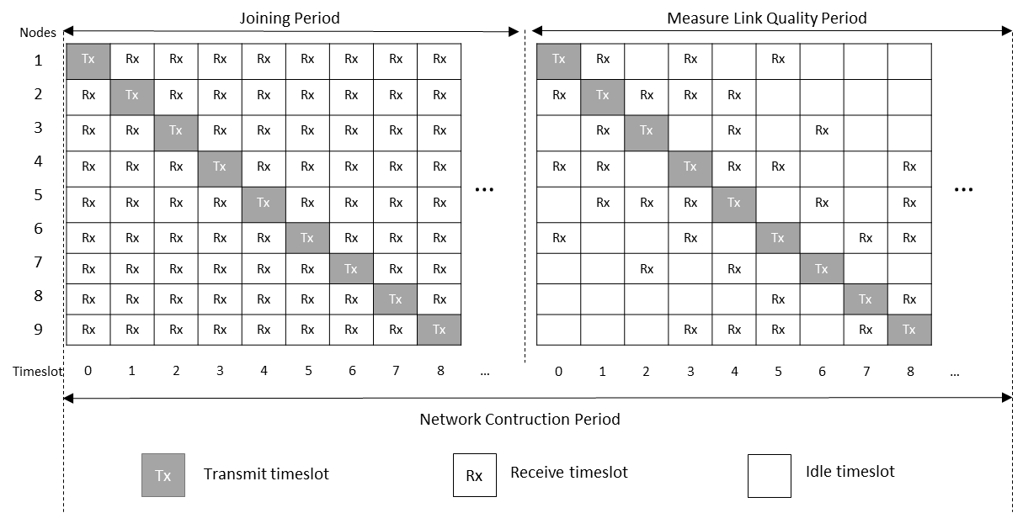
Figure 2. Orchestra’s schedule assigns in NCP.

In the Joining Period (JP), each node autonomous assigns Tx timeslot in its Node-ID – 1 since the timeslot value starts from 0, and Rx timeslot in all the other timeslots. We use the same channel for the Joining Period. The PAN coordinator node start NCP by broadcasting the Enhanced Beacon (EB) packets, all the sensor nodes are in the scanning mode. If any sensor node received the EB packet, it will synchronize with the network and become a broadcaster node to transmit the EB packet to expand the network. The EB packet is created and sent by the joined nodes in each slot frame.

After the Joining Period (JP), we switch all the nodes to Measure Link Quality Period (MLQP) and update the Orchestra schedule by removing Rx of the timeslot which doesn’t have any neighbor nodes.

Table 1. Burstiness Distribution List of link L(1, 4) in MLQP.
Burstiness value | 0 | 1 | 2 | 3 | 4
Burstiness time count | 634 | 129 | 31 | 2 | 1

The number of probes has been predefined for the MLQP. Each node creates Probe Packet(id, sequence) where id is its node id and sequence is a sequence of Probe Packet and broadcast based on Orchestra timeslot in each slot frame until it reaches the number of probes. If the node receiving the Probe Packet, by using the sequence number, the node will count the burstiness value by each sender node then add to the Burstiness Distribution List. For example, Node 1 received Probe Packet from Node 4 with the sequence number is 15, denoted by P(4, 15). The next received Probe Packet from Node 4 is P(4, 18). It means that two consecutive losses happen in sequence numbers 16 and 17 from Node 3, thus burstiness value is 2. For each pair of connected node Ni and Nj, we have the link L(i,j) has the Burstiness Distribution List. For example with link L(1, 4) has PRR is 80%, we have a Burstiness Distribution list as shown in Table 1 with the burstiness value from 0 to 4 and the burstiness time count respectively. With the case, the burstiness value is 0 mean that the burstiness does not happen and node 4 has received the probe packet successfully consecutively 634 times. In case burstiness value is 4 means that the burstiness happens in 4 consecutive transmissions, but it only happens 1 time. In this example, the number of probes is 1000 packets.
  - The Number of Retransmission calculate by Burstiness Distribution List

Figure 3. The distribution of Burstiness compares with link PRR.

Figure 3 shows the distribution of Burstiness compare with link PRR 70%, 80%, and 90% with the number of probes is 5000 packets. The burstiness value is the number of consecutive loss during probes transmission and the burstiness time count is the time burstiness happen. The key idea to calculate the number of retransmission packet is, we define the target PRR for specific application and base on the consecutive loss ratio (packet transmission fail due to a burst), then from the number of probes in the MLQP, we consider the possible loss ratio for the transmission and determine the number of retransmission. For example, to reach the PRR target 99% for the data transmission period, the loss ratio should lower than 1% for each link. If the route has n hops, then every link L(i, j) that the route go through have the loss ration lower than $\sqrt[n]{0.01}$ . With the link has PRR 90% and the number of probes is 5000, it means that 1% of 5000 packets can be lost. The number of allow packet loss is 50. From the distribution of burstiness value, we can calculate the number of retransmission for successful packet transmission is 2 since the consecutive loss of two and three times transmission in 90% link is 42 + 2 = 44 packets, lower than 50 is the number of allowing packet loss. Note that the different links will have a different distribution of burstiness values.

Algorithm 1: Calculate Number Of Retransmission
Input | : | sorted B_{distribution list}, N_{probes}, PRR_{target}, h
Output | : | n_{retransmission}
1 | : | e2e_{loss ratio} 1 − pow(PRR_{target}, 1/h);
2 | : | P_{loss threshold} N_{probes}*e2e_{loss ratio};
3 | : | P_{current loss} 0;
4 | : | for i B_{max} in B_{distribution list} to 0 do
4.1 | : | if P_{loss threshold} ≤ P_{current loss}
4.1.1 | : | n_{retransmission} i;
4.1.2 | : | break;
4.2 | : | Else
4.2.1 | : | P_{current loss} P_{current loss} + B_{distribution list}[i];
4.3 | : | end if
5 | : | end for
6 | : | return n_{retranmission;}

Algorithm 1 calculates the number of retransmission for each link of the node. The input parameter is the sorted Burstiness Distribution List (B_{distribution list}), the number of probes packet (N_{probes}), the target PRR (PRR_{target}), and the hop count (h) of the current node. It returns the number of retransmission (n_{retransmission}) required for successful packet transmission to reach the target PRR. Firstly, base on the hop count of the current node, and target PRR, the end-to-end loss ratio (e2e_{loss ratio}) that we accepted to reach PRR_{target} is calculated by Equation (1):
e2eloss ratio=1- hPRRtarget ( SEQ "equation" \n \* MERGEFORMAT 1)
Then we can calculate the packet loss threshold (P_{loss threshold}) in the MLQP corresponding with the number of probes (N_{probes}) by Equation (2):
Ploss threshold=e2eloss ratio×Nprobes SEQ "equation" \n \* MERGEFORMAT 2

The current packet loss (P_{current loss}) is initialized as 0 means that there is no packet loss. Then we traverse in the Burstiness Distribution List from burstiness max (B_{max}) value. If the packet loss threshold (P_{loss threshold}) lower or equal to the current packet loss (P_{current loss}) we set the number of retransmission by the current burstiness value in the Burstiness Distribution List. Else, the current packet loss will be increased by the number of loss count get from the Burstiness Distribution List.
  - The variation of Burstiness Max
Figure 4. The variation of Burstiness Max value with the config of the number of probes.

To identify the good link to construct the efficient routes, we have to determine the config of the number of probes packet we need to measure in the Measure Link Quality Period. Figure 4 shows the variation of burstiness max value with the config of the number of probes packet.

  - Reliable Routing Protocol using Burstiness Distribution Metric

- EVALUATION
- CONCLUSION

References

[1] B. Sinopoli, C. Sharp, L. Schenato, S. Schaffert, and S. S. Sastry, “Distributed control applications within sensor networks,” Proc. IEEE, vol. 91, no. 8, pp. 1235–1246, Aug. 2003, doi: 10.1109/JPROC.2003.814926.
[2] T. Winter et al., “RPL: IPv6 Routing Protocol for Low-Power and Lossy Networks.,” rfc, vol. 6550, pp. 1–157, 2012.
[3] T. Clausen, J. Yi, and U. Herberg, “Lightweight on-demand ad hoc distance-vector routing-next generation (LOADng): protocol, extension, and applicability,” Comput. Networks, vol. 126, pp. 125–140, 2017.
[4] H.-J. Audéoud and M. Heusse, “Experimental Comparison of Routing Protocols for Wireless Sensors Networks: Routing Overhead and Asymmetric Links,” in 2017 29th International Teletraffic Congress (ITC 29), 2017, vol. 1, pp. 55–62.
[5] S. Munir, S. Lin, E. Hoque, S. M. S. Nirjon, J. A. Stankovic, and K. Whitehouse, “Addressing burstiness for reliable communication and latency bound generation in wireless sensor networks,” in Proceedings of the 9th ACM/IEEE International Conference on Information Processing in Sensor Networks, 2010, pp. 303–314.
[6] K. Srinivasan, M. A. Kazandjieva, S. Agarwal, and P. Levis, “The β-factor: measuring wireless link burstiness,” in Proceedings of the 6th ACM conference on Embedded network sensor systems, 2008, pp. 29–42.
[7] C. Noda, S. Prabh, M. Alves, C. A. Boano, and T. Voigt, “Quantifying the channel quality for interference-aware wireless sensor networks,” ACM SIGBED Rev., vol. 8, no. 4, pp. 43–48, 2011.
[8] H.-J. Audéoud and M. Heusse, “Quick and efficient link quality estimation in wireless sensors networks,” in 2018 14th Annual Conference on Wireless On-demand Network Systems and Services (WONS), 2018, pp. 87–90.
[9] M. Eskola and T. Heikkilä, “Classification of radio channel disturbances for industrial wireless sensor networks,” Ad Hoc Networks, vol. 42, pp. 19–33, 2016.
[10] R. D. Gomes, D. V Queiroz, A. C. Lima Filho, I. E. Fonseca, and M. S. Alencar, “Real-time link quality estimation for industrial wireless sensor networks using dedicated nodes,” Ad Hoc Networks, vol. 59, pp. 116–133, 2017.
[11] G. Kirubasri and N. U. Maheswari, “A study on hardware and software link quality metrics for wireless multimedia sensor networks,” Int. J. Adv. Netw. Appl., vol. 8, no. 3, p. 3103, 2016.
[12] A. Woo and D. E. Culler, Evaluation of efficient link reliability estimators for low-power wireless networks. Computer Science Division, University of California Oakland, Calif, USA, 2003.
[13] D. S. J. De Couto, D. Aguayo, J. Bicket, and R. Morris, “A high-throughput path metric for multi-hop wireless routing,” in Proceedings of the 9th annual international conference on Mobile computing and networking, 2003, pp. 134–146.
[14] C. E. Koksal and H. Balakrishnan, “Quality-aware routing metrics for time-varying wireless mesh networks,” IEEE J. Sel. areas Commun., vol. 24, no. 11, pp. 1984–1994, 2006.
[15] R. Fonseca, O. Gnawali, K. Jamieson, and P. Levis, “Four-bit wireless link estimation.,” in HotNets, 2007.
[16] V. C. Gungor and M. K. Korkmaz, “Wireless link-quality estimation in smart grid environments,” Int. J. Distrib. Sens. Networks, vol. 8, no. 2, p. 214068, 2012.
[17] S. Duquennoy, B. Al Nahas, O. Landsiedel, and T. Watteyne, “Orchestra: Robust mesh networks through autonomously scheduled TSCH,” in Proceedings of the 13th ACM conference on embedded networked sensor systems, 2015, pp. 337–350.

